AP Statistics Name ________________________________
Test: Chapter 11 – Chi-Squared

Multiple Choice – Answer each of the following questions by choosing the one correct answer.
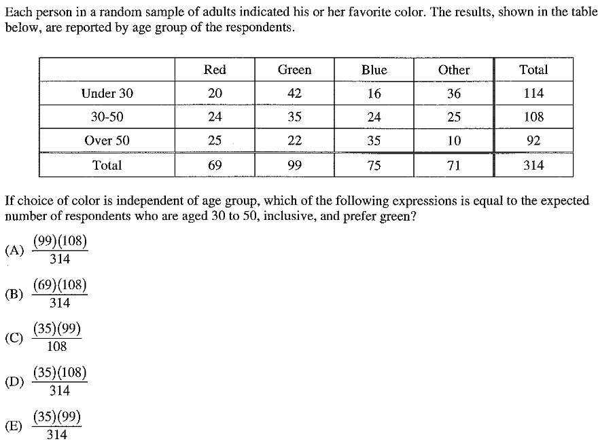
1.)

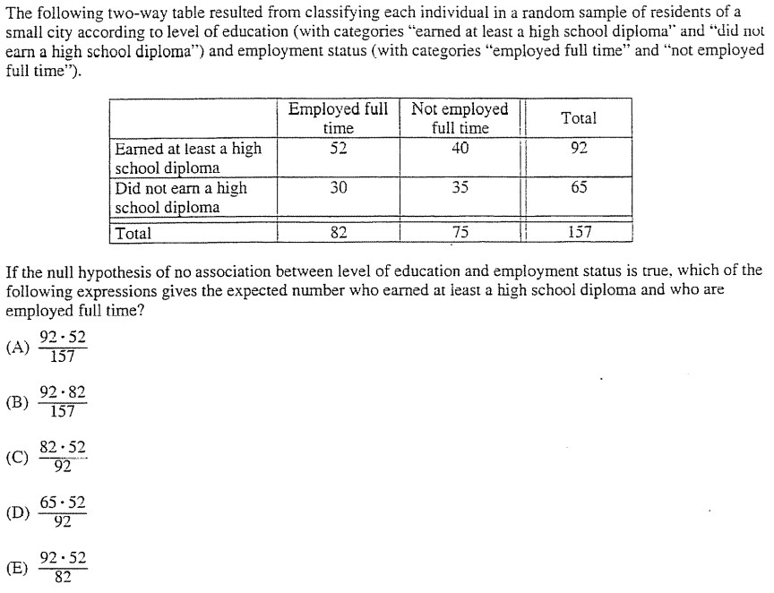
2.)

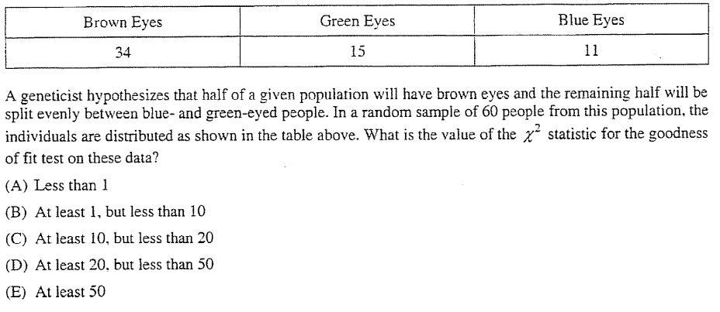
3.)

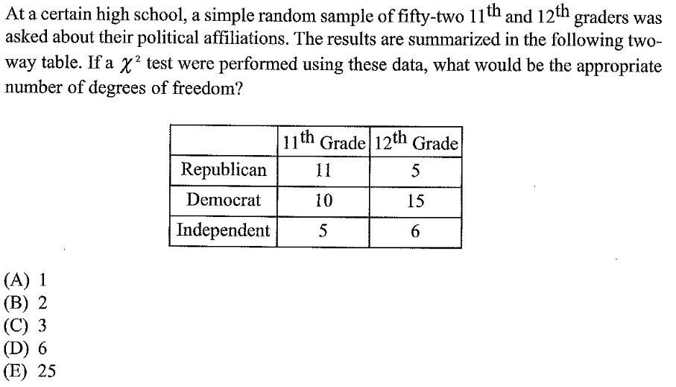
4.)

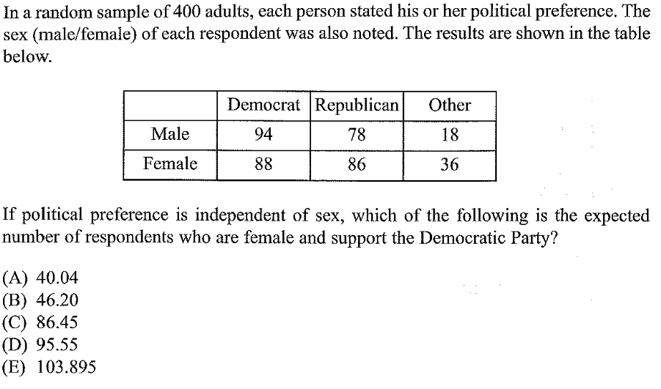
5.)

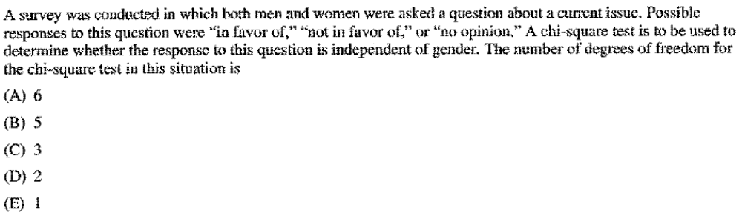
6.)

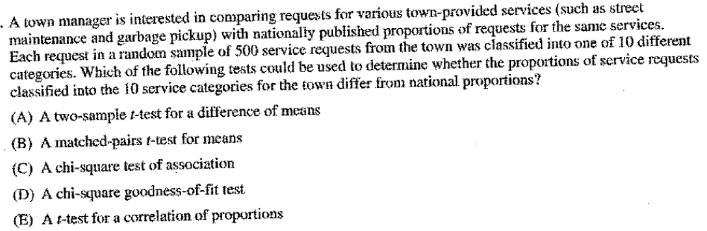
7.)

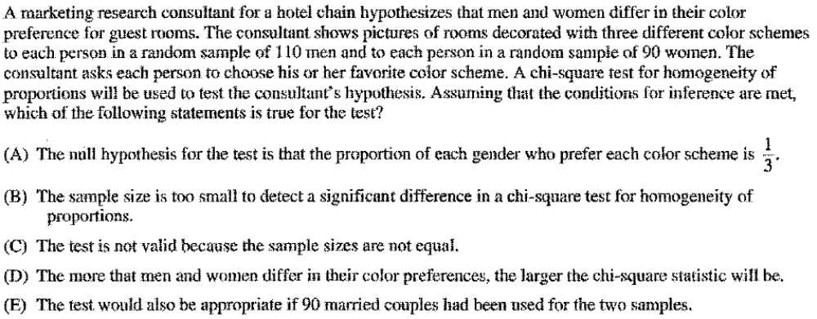
8.)

Please write two additional multiple choice questions so there are ten total. Here are the lesson objectives from this unit for reference. (Ignore the lesson/unit numbers)

Unit 10 - Inference for Categorical Data

Lesson 10.1 - Testing the Distribution of a Categorical Variable
The students will:
- Explain what a chi squared test is and what scenarios they are used for.

Lesson 10.2 – Chi-Squared Test for Goodness of Fit
The students will:
- State the null and alternative hypotheses for a chi squared test for goodness of fit.
- Calculate the chi squared test statistic, degrees of freedom, and p-value for a chi squared test for goodness of fit.
- Run a chi squared test for goodness of fit.

Lesson 10.3 – Chi-Squared Test for Two Way Tables
The students will:
- State the null and alternative hypotheses for a chi squared test based on a two way table.
- Compute expected outcomes for a two way table.
- Calculate the chi squared test statistic, degrees of freedom, and p-value for a chi squared test based on a two way table.
- Run a chi squared test for homogeneity.
- Run a chi squared test for independence.

Free-Response Section
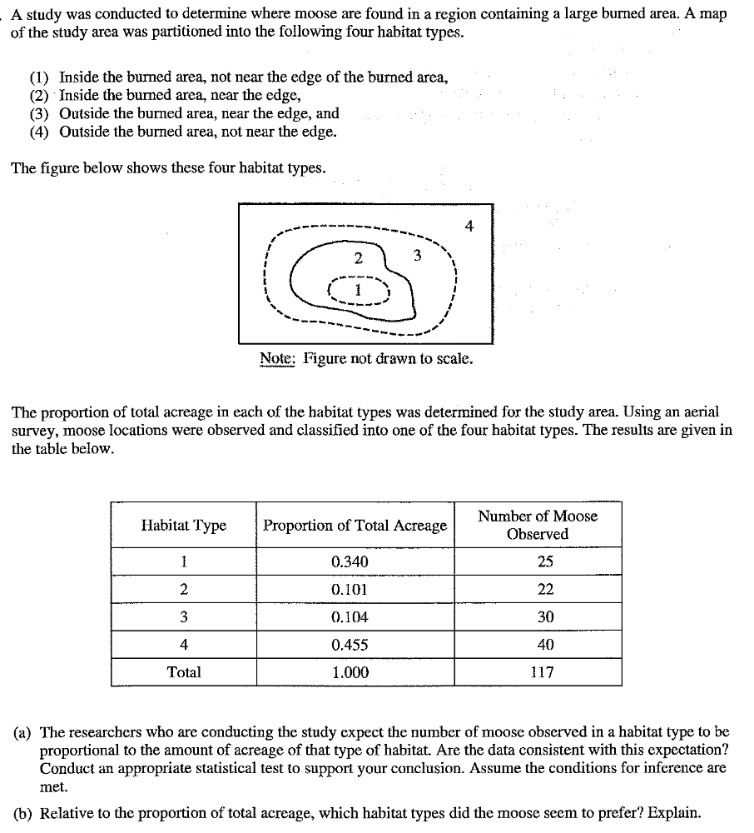
1.)

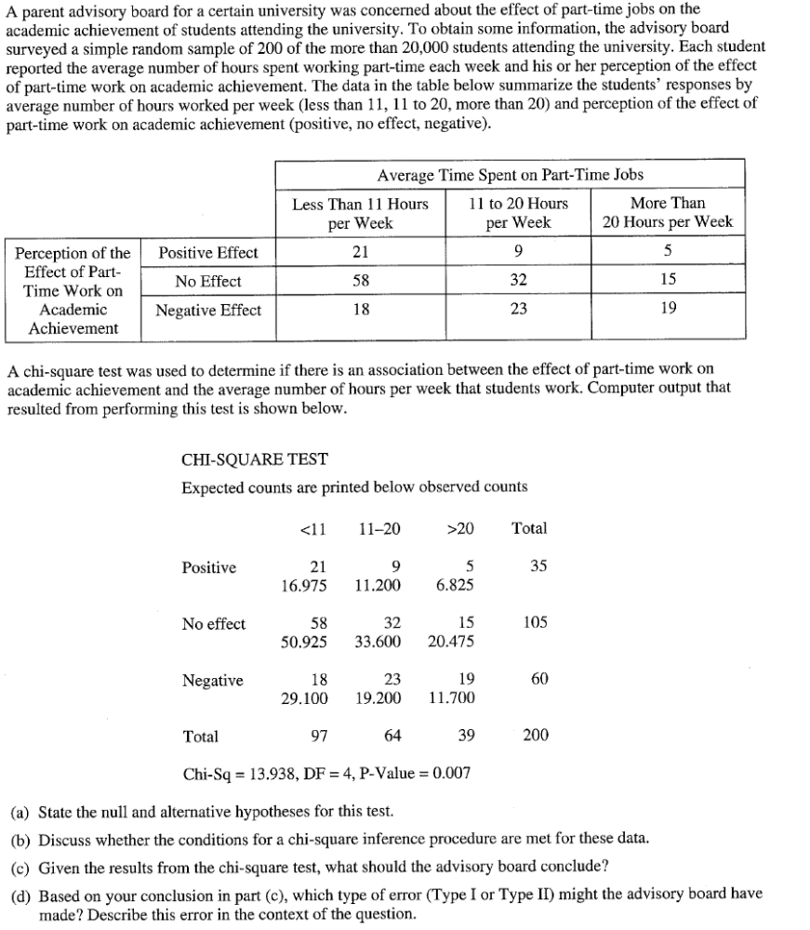
2.)

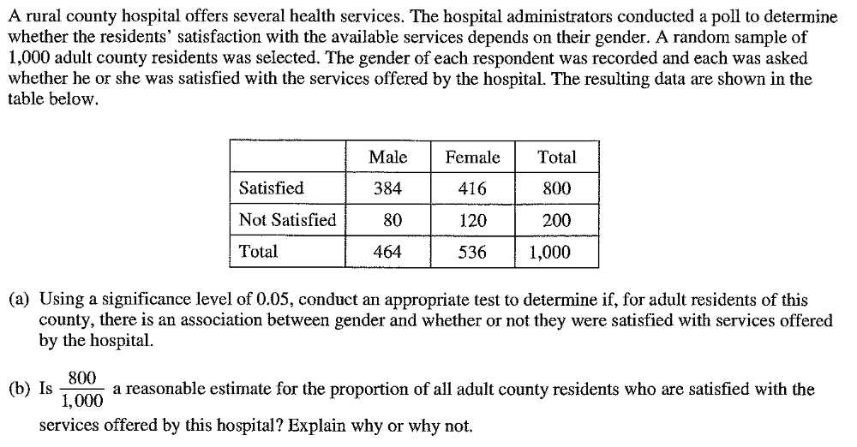
3.)

